

F A N N I N C O U N T Y, T E X A S
REQUEST FOR BIDS

RFB # 2026-001

INVITATION TO BID FOR ROCK AND GRAVEL

SUBMITTAL DEADLINE: May 13, 2026
BEFORE 3:00PM

FANNIN COUNTY
PURCHASING AGENT’S OFFICE
101 E. SAM RAYBURN DR.
SUITE 313
BONHAM, TX 75418
(903) 583-0054

The enclosed REQUEST FOR BID and accompanying SPECIFICATIONS are for your convenience in submitting an offer for the enclosed referenced ROCK & GRAVEL MATERIALS for the County for all Road & Bridge Precincts of Fannin County.

The Commissioners Court of Fannin County, TX reserves the right to accept or reject any/or all bids as it shall deem to be in the best interest of Fannin County. Receipt of any bid shall under no circumstances obligate Fannin County to accept the lowest bid. The award of the contract or contracts shall be made to one or more responsible vendor or vendors whose bid is determined to be the “Lowest and Best” to Fannin County, resulting from a bid or bids providing the best value considering associated direct and indirect costs, including transport, maintenance, reliability, life cycle, warranties, and customer service after a sale.

Bids shall include this RFB and all additional documents submitted. Each bid shall be placed in a separate sealed envelope, manually signed in ink by a person having the authority to bind a vendor to a contract and marked clearly on the outside as outlined below.

SUBMISSION OF BIDS

One (1) original of all bid documents shall be sealed and submitted as vendor's response to:

FANNIN COUNTY
PURCHASING AGENT
LEE SWAFFORD
101 E. SAM RAYBURN DR.
SUITE 313
BONHAM, TX 75418
(903) 583-0054

SEALED BIDS MUST BE FILED IN THE COUNTY PURCHASING AGENT OFFICE BEFORE 3:00 PM Wednesday, May 13, 2026.

Label envelope: RFB # 2026-001 ROCK AND GRAVEL

SEALED BIDS SHALL BE OPENED AT 3:15 PM WEDNESDAY, MAY 13, 2026 IN THE FANNIN COUNTY PURCHASING AGENT’S OFFICE, 101 E. SAM RAYBURN DR. SUITE 313, BONHAM, TX 75418.

Notification for bidding to supply Rock and Gravel for Fannin County has been properly advertised as required by law. Bid forms containing required specifications shall be furnished to persons or firms requesting the forms from:

Email: Lee Swafford purchasing@fanninco.net

Phone: (903) 583-0054

Online: www.co.fannin.tx.us/page/fannin.County.Purchasing

SELECTION AND AWARD PROCESS
The Purchasing Agent shall present opened bids received to the Commissioners Court. The Commissioners Court may consider the pickup and delivery locations of the bidders and the cost to the county delivering or hauling the material to be purchased. The Commissioners Court may award contract or contracts for the purchase of road construction material to more than one bidder if each of the selected bidders submits the lowest and best bids for a particular location or type of material. A contract or contracts may be awarded to one or more bidders who submit the lowest and best bid or bids for the county.

RIGHT OF THE COUNTY TO CANCEL REQUEST FOR BID, TO ELECT NOT TO AWARD, TO REJECT SUBMITTALS, AND TO WAIVE INFORMALITIES OR IRREGULARITIES.

The county expressly reserves the right to cancel the RFB at any time, to elect not to award contracts cited in the RFB, to reject any or all submittals, to waive any informality or irregularity in any submittal received, and to be the sole judge of the merits of the respective submittals received.

NO INDIVIDUAL OF ANY COUNTY DEPARTMENT HAS THE AUTHORITY TO LEGALLY AND/OR FINANCIALLY COMMIT THE COUNTY TO ANY CONTRACT, AGREEMENT OR PURCHASE ORDER FOR GOODS OR SERVICES, UNLESS SPECIFICALLY SANCTIONED BY THE REQUIREMENTS OF THE REQUEST FOR BID.

ADDENDA TO THE REQUEST FOR BID
Requests for interpretations and clarifications of the RFB may only be made in writing. All requests must be submitted in writing to Julie Criswell, Purchasing Agent, at lswafford@fanninco.net.

It shall be the responsibility of each vendor, prior to submitting the competitive bid, to check the website to confirm if addenda were issued and to make such addenda a part of the competitive bid.

LATE BIDS
Bids received in the Purchasing Office after submission deadline shall be returned unopened and will be considered void and unacceptable. Fannin County is not responsible for lateness of mail, carrier, etc., and time/date stamp in the Purchasing Office shall be the official time of receipt.

ALTERING BIDS
Any interlineation, alteration, or erasure made before receiving time must be initialed by the signer of the proposal, guaranteeing authenticity.

WITHDRAWAL OF BID
A bid may not be withdrawn or cancelled by the contractor for a period of sixty (60) days following the date designated for the receipt of bid, and contractors so agree upon submittal of their bid.

BID OPENING
Bids will be received and publicly opened by the Purchasing agent at the location, date, and time stated above. Contractors, their representatives, and interested persons may be present. All bids shall be kept on file and available for public inspection after the contact or contracts is awarded until the first anniversary of the date of opening.

SALES TAX
Fannin County, Texas is by statute exempt from the state sales tax and federal excise tax; therefore, the proposal price shall not include taxes.

CONFLICT OF INTEREST
No public official or Fannin County employee shall have interest in this contract, in accordance with Vernon, Texas Codes Annotated, Local Government Codes Title 5, Submitted C, Chapter 171.

- BID SPECIFICATIONS

*GRADATION OF MATERIAL **FILTER BLANKET MATERIAL FOR
BED RIP RAP (LARGE ROCK)
GRADATION OF MATERIAL

SIZE PERCENTAGE SIZE PERCENTAGE

1 ½” 100% 4” 100%
1” 95 – 100% 2” 60 – 90%
½” 25 – 60% 1” 40 – 70%
#3 0 – 10% 3/8” 15 – 40%
#8 0 – 5% #3 0 – 15%

FANNIN COUNTY COMMISSIONERS’ RESERVE THE RIGHT TO REJECT ANY OR ALL PRODUCTS AT ANY TIME THAT THE PRODUCTS DO NOT MEET THE APPROVAL OF THE COMMISSIONERS, COLLECTIVELY OR INDIVIDUALLY.

THE CONTRACT EFFECTIVE DATES WILL BE FOR ONE FULL YEAR FROM THE DATE OF ACCEPTANCE BY THE FANNIN COUNTY COMMISSIONERS COURT.

ROCK WILL BE PURCHASED BASED ON LOWEST PRICE AVAILABLE.

COMPANY NAME ________________________________________

ADDRESS ________________________________________

________________________________________

PHONE

EMAIL

SUCCESSFUL BIDDER SHALL defend, indemnify and hold harmless Fannin County and all its officers, agents and employees from all suits, actions, or other claims of any character, name and description brought for or on account of any injuries or damages received or sustained by any person, persons, or property on account of any negligent act or fault of the successful bidder, or of any agent, employee, subcontractor or supplier in the execution of, or performance under, any contract which may result from bid award. Successful bidder shall pay any judgment with cost which may be obtained against Fannin County growing out of such injury or damages.

Fannin County reserves the right to accept and or reject any and all bids.

RETURN BID TO:

Mail:
Fannin County Purchasing
101 East Sam Rayburn, Suite 313
Fannin County Courthouse
Bonham, TX 75418

Sealed Bids shall be received no later than:

3:00 P.M., May 13, 2026
MARK ENVELOPE or SUBJECT LINE: "BID #2026-001 - Rock and Gravel”

BID FORM

THIS BID FORM IS REQUIRED TO BE SUBMITTED AND SIGNED BY THE INDIVIDUAL THAT IS AUTHORIZED TO EXECUTE CONTRACTS FOR THE COMPANY.

I, WE, ___________________________________ (COMPANY NAME)

___________________________________ (ADDRESS)

___________________________________

___________________________________ (PHONE)

___________________________________ (FAX)

HEREBY AGREE TO DELIVER TO THE COUNTY OF FANNIN, TEXAS, ROCK & GRAVEL IN ACCORDANCE WITH THE ATTACHED SPECIFICATIONS.

_______________________________
SIGNATURE

_______________________________
PRINT NAME

_______________________________
TITLE

Bidder Shall Sign and Return Pages 1 through 21 of Bid Package and All Documentation Required by the Invitation for Bid.

BID AFFIDAVIT

The undersigned certifies that the bid prices contained in this bid have been carefully reviewed and are submitted as correct and final. The period of acceptance of this bid will be no more than sixty (60) calendar days from the date of the bid opening.

STATE OF COUNTY OF

BEFORE ME, the undersigned authority, a Notary Public in and

for the State of , on this day personally appeared

, who
(name)
after being by me duly sworn, did depose and say:

"I, am a
(name)
duly authorized officer of/agent for ;
(name of firm)
and have been duly authorized to execute the foregoing

on behalf of the said .
(name of firm)

I hereby certify that the foregoing bid has not been prepared in collusion with any other bidder or other person or persons engaged in the same line of business prior to the official opening of this bid. Further, I certify that the bidder is not now, nor has been for the past six (6) months, directly or indirectly concerned in any pool or agreement or combination, to control the price of the goods/services bid on, or to influence any person or persons to bid or not to bid thereon."

Name and address of bidder:

Telephone #

by: Title:
(print name)
Signature:

SUBSCRIBED AND SWORN to before me by the above-named

on

this the day of 20 .

Notary Public in and for
the State of

REFERENCES
LIST THREE (3) COMPANIES OR GOVERNMENTAL AGENCIES WHERE THESE COMMODITIES HAVE BEEN PROVIDED:

1. COMPANY NAME:______________________________________________

ADDRESS:__________________________TELEPHONE NO.:___________

CONTACT PERSON:___________________TITLE:___________________

EMAIL:

2. COMPANY NAME:______________________________________________

ADDRESS:__________________________TELEPHONE NO.:___________

CONTACT PERSON:___________________TITLE:___________________

EMAIL:

3. COMPANY NAME:______________________________________________

ADDRESS:__________________________TELEPHONE NO:____________

CONTACT PERSON:___________________TITLE:___________________

EMAIL:

Any questions concerning this bid must be directed in writing to Julie Criswell, Fannin County Purchasing Agent at lswafford@fanninco.net.

Comments/Exceptions: ________________________________________________________________________________________________________________________________________________________________________________________________________________________________________________________________________________________________________________________
________________________________________________________________________________________________________

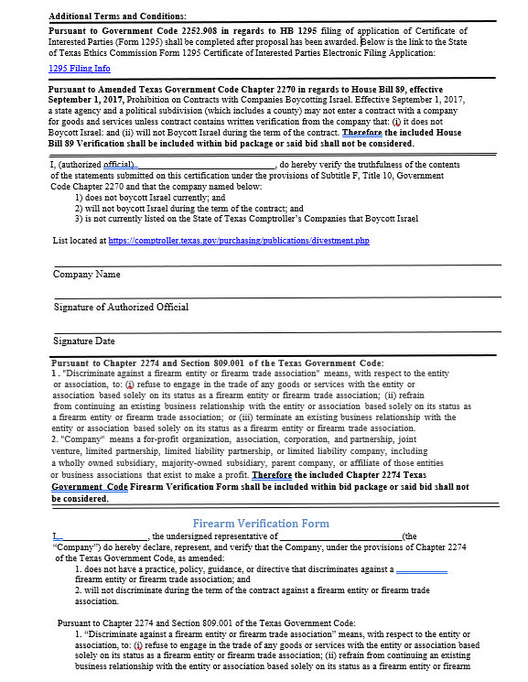
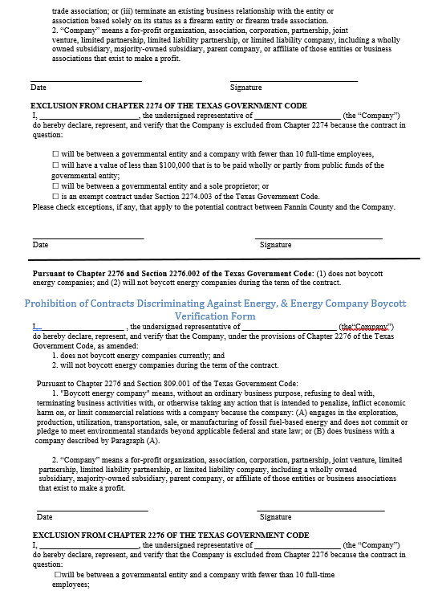
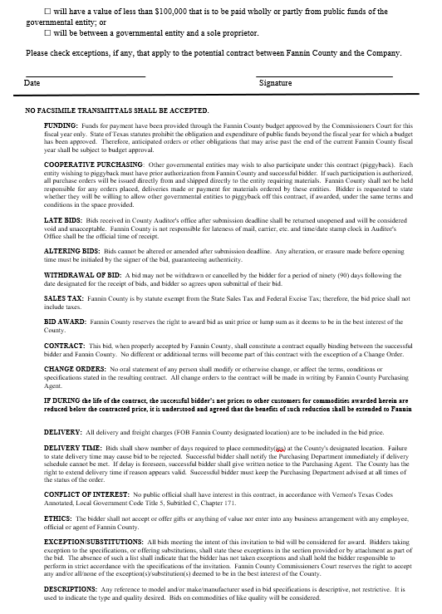
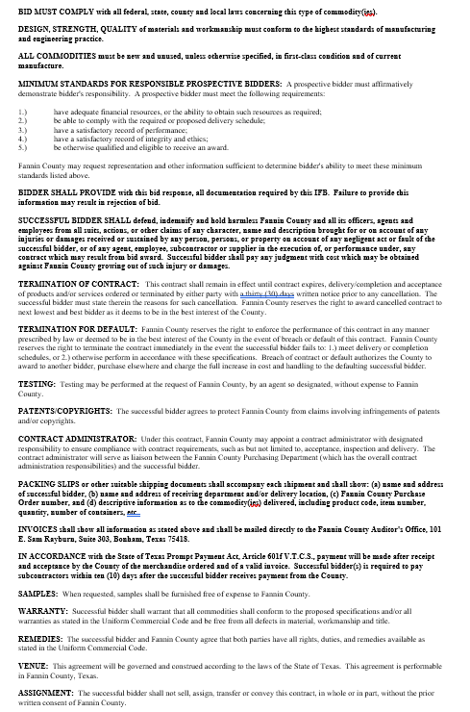
FANNIN COUNTY 2026-001 RFB ROCK AND GRAVEL BID PRICE SHEET

Fannin County Precinct One Barn | Bid FOB Pit | Bid FOB Barn | Hauling Only
8665 Hwy. 56 West | Per Ton | Per Ton | Designated
Savoy, TX 75479 |  | Price to Include | Location
 |  | Rock & Hauling | Per Mile
Mixed Gravel 3/8 - 1 1/2
Dirty Rock 3/4 - 1 1/2
Dirty Oversized Rock 3"
Clay Balls
Crushed White Rock
Crushed Flex Base 2" TXDOT #249
1 1/2" #57 ASTM
4" Special #3
1 1/2" Crusher Run #3
2 1/2" Crusher Run
Screenings
TY B Grade 3
TY B Grade 4
TY B Grade 5
3/8" Chips
5/8" Chips
Select Riprap 12"
Select Riprap 18" or More
Road Gravel
Railroad Rock 2" ASTM #3
1 3/4" Clean Rock
1 3/4" Crusher Run
1 3/4" Quarry Run Base
1 1/2" Class B
3/4" #1 Cover
Non-Spec S.L. Riprap
3/4" Crusher Run
2" ASTM Size #3
Dry Surge Approx. 6"
Shot Down Rock
Fine Surge Approx. 3"
1 1/2" ODOT Base Type A
Flint Rock
3/4" Clean Rock
1 1/2" Clean Rock
3/8" #2 Cover
5/8" #3 Cover
3/8" Hard Road Gravel
5/8" Hard Road Gravel
Semi-Washed Native 1 1/2" Road Gravel
Fly Ash/Flex Base Rock
1 1/2/" Flex Base
1" Utility Stone
3/8" Screenings
3" x 5" Entrance Rock
Recycle Asphalt
Asphalt Dumps
Fannin County Precinct Two Barn | Bid FOB Pit | Bid FOB Barn | Hauling Only
500 North Hwy. 69 | Per Ton | Per Ton | Designated
Leonard, TX 75452 |  | Price to Include | Location
 |  | Rock & Hauling | Per Mile
Mixed Gravel 3/8 - 1 1/2
Dirty Rock 3/4 - 1 1/2
Dirty Oversized Rock 3"
Clay Balls
Crushed White Rock
Crushed Flex Base 2" TXDOT #249
1 1/2" #57 ASTM
4" Special #3
1 1/2" Crusher Run #3
2 1/2" Crusher Run
Screenings
TY B Grade 3
TY B Grade 4
TY B Grade 5
3/8" Chips
5/8" Chips
Select Riprap 12"
Select Riprap 18" or More
Road Gravel
Railroad Rock 2" ASTM #3
1 3/4" Clean Rock
1 3/4" Crusher Run
1 3/4" Quarry Run Base
1 1/2" Class B
3/4" #1 Cover
Non-Spec S.L. Riprap
3/4" Crusher Run
2" ASTM Size #3
Dry Surge Approx. 6"
Shot Down Rock
Fine Surge Approx. 3"
1 1/2" ODOT Base Type A
Flint Rock
3/4" Clean Rock
1 1/2" Clean Rock
3/8" #2 Cover
5/8" #3 Cover
3/8" Hard Road Gravel
5/8" Hard Road Gravel
Semi-Washed Native 1 1/2" Road Gravel
Fly Ash/Flex Base Rock
1 1/2/" Flex Base
1" Utility Stone
3/8" Screenings
3" x 5" Entrance Rock
Recycle Asphalt
Asphalt Dumps
Fannin County Precinct Three Barn | Bid FOB Pit | Bid FOB Barn | Hauling Only
18101 East FM 1396 | Per Ton | Per Ton | Designated
Honey Grove, TX 75446 |  | Price to Include | Location
 |  | Rock & Hauling | Per Mile
Mixed Gravel 3/8 - 1 1/2
Dirty Rock 3/4 - 1 1/2
Dirty Oversized Rock 3"
Clay Balls
Crushed White Rock
Crushed Flex Base 2" TXDOT #249
1 1/2" #57 ASTM
4" Special #3
1 1/2" Crusher Run #3
2 1/2" Crusher Run
Screenings
TY B Grade 3
TY B Grade 4
TY B Grade 5
3/8" Chips
5/8" Chips
Select Riprap 12"
Select Riprap 18" or More
Road Gravel
Railroad Rock 2" ASTM #3
1 3/4" Clean Rock
1 3/4" Crusher Run
1 3/4" Quarry Run Base
1 1/2" Class B
3/4" #1 Cover
Non-Spec S.L. Riprap
3/4" Crusher Run
2" ASTM Size #3
Dry Surge Approx. 6"
Shot Down Rock
Fine Surge Approx. 3"
1 1/2" ODOT Base Type A
Flint Rock
3/4" Clean Rock
1 1/2" Clean Rock
3/8" #2 Cover
5/8" #3 Cover
3/8" Hard Road Gravel
5/8" Hard Road Gravel
Semi-Washed Native 1 1/2" Road Gravel
Fly Ash/Flex Base Rock
1 1/2/" Flex Base
1" Utility Stone
3/8" Screenings
3" x 5" Entrance Rock
Recycle Asphalt
Asphalt Dumps
Fannin County Precinct Four Barn | Bid FOB Pit | Bid FOB Barn | Hauling Only
1369 East Hwy. 56 | Per Ton | Per Ton | Designated
Bonham, TX 75418 |  | Price to Include | Location
 |  | Rock & Hauling | Per Mile
Mixed Gravel 3/8 - 1 1/2
Dirty Rock 3/4 - 1 1/2
Dirty Oversized Rock 3"
Clay Balls
Crushed White Rock
Crushed Flex Base 2" TXDOT #249
1 1/2" #57 ASTM
4" Special #3
1 1/2" Crusher Run #3
2 1/2" Crusher Run
Screenings
TY B Grade 3
TY B Grade 4
TY B Grade 5
3/8" Chips
5/8" Chips
Select Riprap 12"
Select Riprap 18" or More
Road Gravel
Railroad Rock 2" ASTM #3
1 3/4" Clean Rock
1 3/4" Crusher Run
1 3/4" Quarry Run Base
1 1/2" Class B
3/4" #1 Cover
Non-Spec S.L. Riprap
3/4" Crusher Run
2" ASTM Size #3
Dry Surge Approx. 6"
Shot Down Rock
Fine Surge Approx. 3"
1 1/2" ODOT Base Type A
Flint Rock
3/4" Clean Rock
1 1/2" Clean Rock
3/8" #2 Cover
5/8" #3 Cover
3/8" Hard Road Gravel
5/8" Hard Road Gravel
Semi-Washed Native 1 1/2" Road Gravel
Fly Ash/Flex Base Rock
1 1/2/" Flex Base
1" Utility Stone
3/8" Screenings
3" x 5" Entrance Rock
Recycle Asphalt
Asphalt Dumps

